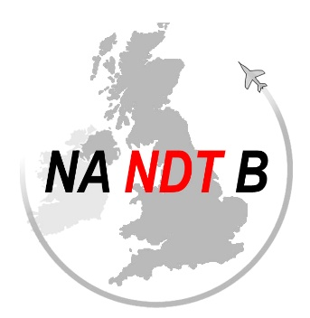

© UK NANDTB

UK NANDTB ADVISORY AD-016_frm_A

Please complete the following details for all applications for examination by alternative processes in accordance with the guidance of UK NANDTB AD016
Please submit completed form to UKNANDTB@bindt.org before 12 noon on Friday of the week prior to the proposed examination date where it will be reviewed by representatives of the UK board and where required (for part 145 organisations) will be sent to the CAA for additional approval.

UKNANDTB Approval: APPROVED/DECLINED

CAA Approval: APPROVED/DECLINED
DATE:
DATE OF APPLICATION
OUTSIDE AGENCY DETAILS
AGENCY
Primary Contact
Email/Phone
Procedure Reference
CLIENT DETAILS
Company Name
Country
PART 21 |  | NADCAP |  |  | PART 145
Primary Contact
Email/Phone
Appointed Invigilator Position & Name
For the purposes of UK NANDTB & UK CAA oversight please specify live monitoring platform and approximate time frame of exams
CANDIDATE 1 DETAILS
Name
Method and Level
Proposed Examination Date

CANDIDATE 2 DETAILS
Name
Method and Level
Proposed Examination Date
CANDIDATE 3 DETAILS
Name
Method and Level
Proposed Examination Date
(Further candidates may be added as necessary)
JUSTIFCATION: (to include all reasons why an examination under normal controls cannot take place)

