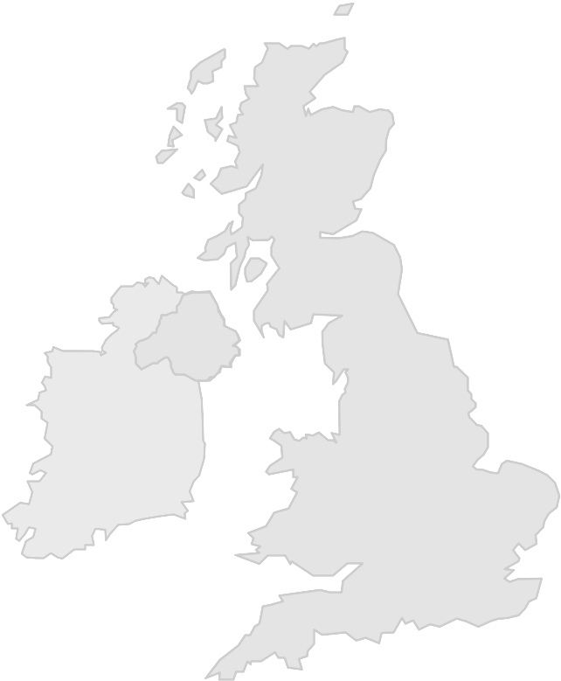
The 2006 Report of the UK National Aerospace NDT Board
NA NDT B

Secretariat provided by
The British Institute of NDT
1 Spencer Parade, Northampton
NN1 5AA, United Kingdom
Tel: +44(0)1604-259-056
Fax: +44(0)1604-231-489
E-mail: john.thompson@bindt.org

Reporting period: 24 months to 31 December 2006

PREAMBLE
The United Kingdom National Aerospace NDT Board (The Board), which is an independent national aerospace body chartered by UK aerospace prime contractors and design authorities, and is recognised by the Civil Aviation Authority (CAA), satisfies the United Kingdom requirement for a National Aerospace NDT Board as defined in EN 4179 and EASA Part 145.
The Board seeks to:
- act as custodians for all matters related to employer based personnel training and certification standards in the aerospace sector;
- provide a system for recognition of organisations implementing such standards;
- provide a system for recognition of organisations seeking to provide training and/or qualification examinations meeting the requirements of such standards;
- provide a system for ensuring that company written practices conform with such standards;
- provide a system for assessing organisations for compliance with a company written practice designed to conform with such standards;
- provide a mechanism for interpretation, adjudication and arbitration in cases of dispute regarding the implementation of such standards;
- set standards for the introduction of new and emerging technologies not currently covered by such standards;
- seek recognition of it’s schemes with other European National Aerospace NDT Boards, and with any other pertinent body in order to benefit the United Kingdom Aerospace industry and to minimise duplication and multiple audit where possible.
The Board also acts as the Aerospace Industry Advisory Board that formulates the policy framework within which the PCN Aerospace Personnel Certification Scheme is operated, maintains an overview of the implementation of its policies, sets up working groups and committees with terms of reference, and maintains an overview of the assessment and accreditation by BINDT of NDT personnel Qualifying Agencies.

BACKGROUND TO THE FORMATION OF THE BOARD
A meeting of interested parties was held at the British Institute of NDT, 1 Spencer Parade, Northampton on Wednesday 3 April 1996 to discuss prEN4179, its implications for the United Kingdom aerospace industry, and the need to form a National Aerospace NDT Board (NANDTB) to regulate the implementation of the standard. The meeting concluded that there was general support for the formation of a board, but there was no real perceived need at that time.
A further meeting was held at the British Institute of NDT on 22 May 2000 to discuss perceived concerns related to the implementation of the now published EN4179 in the UK. The meeting concluded that potential problems could materialise and that preventive action of some kind would be desirable before, rather than after the implementation of the standard. It was decided to produce a brief discussion document listing the perceived concerns without recommending specific recommendations or solutions.
On 28th June 2004, a meeting of interested parties took place at Airbus UK, Filton, Bristol, with the objective of developing and approving constitutional documents for the formation of a UK Board. A series of meetings followed during 2004 and 2005 and, on Monday 4th October 2004, the UK NANDTB held its inaugural meeting at the premises of Messier Dowty in Gloucestershire.

MEMBERSHIP
The contributions of member organisations and their nominated representatives is essential to the credibility of the UK NANDTB, and The Board expresses gratitude to those organisations and individuals who contribute by their membership. The following is a list of the organisations in membership of The Board at 31st December 2006:
- Agusta Westland (member) represented by Mr. Phil Berkley
- Airbus UK (member) represented by Messrs. John Hewitt and Trevor Hiscox
- BAE Systems (member) represented by Mr. Chris Dootson
- Bombardier (member) represented by Messrs. Eric McIlroy and Bobby Scott
- British Airways (member) represented by Mr. Brian Williams (until August) and Mr. Roger Hogarth
- British Institute of Non-Destructive Testing (co-opted) represented by John Thompson (also the Secretary to the Board)
- Civil Aviation Authority (observer) represented by Messrs. Mark Barker and Ian Chapman
- Honeywell (member) represented by Mr. Stanley Gane
- Messier Dowty (member) represented by Mr. Keith Keith Phillips (until September) and Mr. Colin Thomas
- Part 145 approved organisations, Outside Agencies and SIG members (co-opted) represented by Mr. Graham McCully
- Rolls Royce (member) represented by Mr. Jon Biddulph
- UK Training & Examination Group for Non-Destructive Testing & Inspection Organisations (co-opted) represented by Mr. Colin Thomas

THE WORK OF THE BOARD UP TO 31 DECEMBER 2005
The Board maintained a high profile and level of activity through 2005, taking control of PCN aerospace examinations and approving the publication of PCN/AERO, which was designed to satisfy the certification criteria of EN 473 as well as the qualification criteria of EN 4179. The Board recognised that PCN aerospace NDT personnel certification satisfied the needs of the EASA part 145 maintenance organisations.
During 2003, the British Institute of NDT had developed a system for assessment and approval of ‘Outside Agencies’ providing training, examinations and other services to employers that certify the competence of their NDT personnel within a 2nd party system, such as SNT-TC-1A or EN 4179. The BINDT criteria for assessment and approval of Outside Agencies was reviewed and revised by the NAndtB, and was republished following approval by the NAndtB early in 2005.
During that year, the number of BINDT Accredited Outside Agencies increased to five, and the draft revision of the CAA’s airworthiness notice GR23 included a transitional requirement for all internal and external NDT qualification training and examinations to come under the control of the UK Aerospace NDT Board by September 2007.
In November 2005, The Board staged a seminar on the topics of European Aviation Safety Agency regulations (parts 21 and 145), EN 4179 and NANDTB, which was hosted by the UK CAA at their Gatwick Airport premises, and which was attended by 76 registered delegates representing 14 countries. At this event it was widely agreed to establish a forum for the various NANDTB.

THE WORK OF THE BOARD IN THE 12 MONTHS TO 31 DECEMBER 2006
During this period The Board:
- provided assistance to the UK CAA during the revision of its Airworthiness Requirements for NDT in Maintenance (CAP 747 GR23) and Design and Production (CAIP Leaflet 4-10);
- reviewed the recently drafted and approved PCN/AERO requirements and, in the light of the recent publication of EN 4179:2005, agreed a number of amendments;
- agreed a transition from PCN/GEN Appendix A to PCN/AERO under which PCN Aerospace certificates issued as a result of examinations or recertification commenced on or before 31st March 2006 would be recognised until 31st March 2011;
- reviewed and approved PCN aerospace examination papers;
- agreed that the Board might be presented with specific proposals concerning the introduction into the aerospace industry of new NDT technology which it could evaluate and perhaps approve in order to assist industry in its introduction;
- witnessed BINDT audits of Authorised Qualifying Bodies (PCN Test Centres) and Outside (Qualifying) Agencies;
- ensured that all necessary specifications, procedures, and documents were in place to support the assessment and accreditation on internal EN 4179 qualification systems;
- on request from industry, provided interpretations and guidance related to EN 4179;
- participated in the first European Forum for national Aerospace NDT Boards, which was convened in Paris on 1st December 2006.

