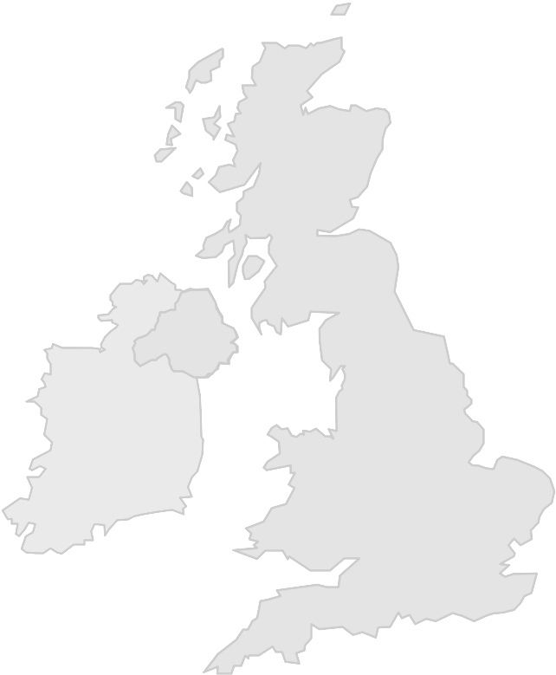
The 2007 Annual Report of the UK National Aerospace NDT Board
NA NDT B

Secretariat provided by
The British Institute of NDT
1 Spencer Parade, Northampton
NN1 5AA, United Kingdom
Tel: +44(0)1604-259-056
Fax: +44(0)1604-231-489
E-mail: john.thompson@bindt.org

Reporting period: 12 months to 31 December 2007 Rev: 2007-11-14

PREAMBLE
The United Kingdom National Aerospace NDT Board (The Board), which is an independent national aerospace body chartered by UK aerospace prime contractors and design authorities, and is recognised by the Civil Aviation Authority (CAA), satisfies the United Kingdom requirement for a National Aerospace NDT Board as defined in EN 4179 and EASA Part 145.
The Board seeks to:
- act as custodians for all matters related to employer based personnel training and certification standards in the aerospace sector;
- provide a system for recognition of organisations implementing such standards;
- provide a system for recognition of organisations seeking to provide training and/or qualification examinations meeting the requirements of such standards;
- provide a system for ensuring that company written practices conform with such standards;
- provide a system for assessing organisations for compliance with a company written practice designed to conform with such standards;
- provide a mechanism for interpretation, adjudication and arbitration in cases of dispute regarding the implementation of such standards;
- set standards for the introduction of new and emerging technologies not currently covered by such standards;
- seek recognition of it’s schemes with other European National Aerospace NDT Boards, and with any other pertinent body in order to benefit the United Kingdom Aerospace industry and to minimise duplication and multiple audit where possible.
The Board also acts as the Aerospace Industry Advisory Board that formulates the policy framework within which the PCN Aerospace Personnel Certification Scheme is operated, maintains an overview of the implementation of its policies, sets up working groups and committees with terms of reference, and maintains an overview of the assessment and accreditation by BINDT of NDT personnel Qualifying Agencies.

MEMBERSHIP
The contributions of member organisations and their nominated representatives is essential to the credibility of the UK NANDTB, and The Board expresses gratitude to those organisations and individuals who contribute by their membership. The following is a list of the organisations in membership of The Board at 31st December 2007:
- Agusta Westland (member) represented by Mr. Phil Berkley
- Airbus UK (member) represented by Messrs. John Hewitt and Trevor Hiscox
- BAE Systems (member) represented by Mr. Chris Dootson
- Bombardier (member) represented by Messrs. Eric McIlroy and Bobby Scott
- British Airways (member) represented by Mr. Roger Hogarth
- British Institute of Non-Destructive Testing (co-opted) represented by John Thompson (also the Secretary to the Board)
- Civil Aviation Authority (observer) represented by Messrs. Mark Barker and Ian Chapman
- Honeywell (member) represented by Mr. Stanley Gane
- Messier Dowty (member) represented by Messrs. Bob Murrell and Colin Thomas
- Part 145 approved organisations, Outside Agencies and SIG members (co-opted) represented by Mr. Graham McCully
- Rolls Royce (member) represented by Mr. Jon Biddulph
- UK Training & Examination Group for Non-Destructive Testing & Inspection Organisations (co-opted) represented by Mr. Colin Thomas

THE WORK OF THE BOARD IN THE 12 MONTHS TO 31 DECEMBER 2007
During this period The Board:
- maintained the content of its website at www.bindt.org/NANDTB in order to inform the industry on matters dealt with by the Board;
- held four meetings (minutes of meetings are uploaded to the Board’s website for public access):
  - The 11th meeting was held at the premises of Bombardier (Belfast) on 22nd February 2007,
  - The 12th meeting was held at the premises of Material Measurements Limited (Reigate) on 24th May 2007,
  - The 13th meeting was held at the premises of BAE (Warton) on 16th August 2007, and
  - The 14th meeting was held at the premises of Airbus UK (Filton) on 22 November 2007.
The Board expresses gratitude to the member organisations for providing facilities and support for its meetings.
- agreed the methodology for the qualification and approval of personnel implementing testing using technologies not presently covered by EN 4179, and monitored the application of this methodology used in the application of Infrared Thermography (IRT);
- provided assistance to the UK CAA during the revision of its Airworthiness Requirements for NDT in Maintenance and Design and Production (CAP 747 GR23);
- Drafted proposals for common training and examination datasheets for use by all Outside Agencies in order to standardise the information provided by such agencies to their clients;
- agreed that the Board might be presented with specific proposals concerning the introduction into the aerospace industry of new NDT technology which it could evaluate and perhaps approve in order to assist industry in its introduction;
- approved the publication on its website of a PowerPoint file and a Nadcap auditor advisory NDT06-0007 concerning the acceptance of central certification qualification examinations;
- continued to discharged its responsibility to control aerospace sector qualification examinations through the oversight of audits of Authorised Qualifying Bodies (PCN Test Centres) and Outside (Qualifying) Agencies:
  - Argyll Ruane Limited, March 2007;
  - Material Measurements Limited, May 2007; and
  - TWI Examination Services, November 2007.
- drafted and approved Terms of Reference for co-opted members;
- on request from industry, provided interpretations and guidance related to EN 4179;
- participated in the second and third meetings of the European Forum for National Aerospace NDT Boards, which were convened in Istanbul (July 2007) and Rome (November 2007).

